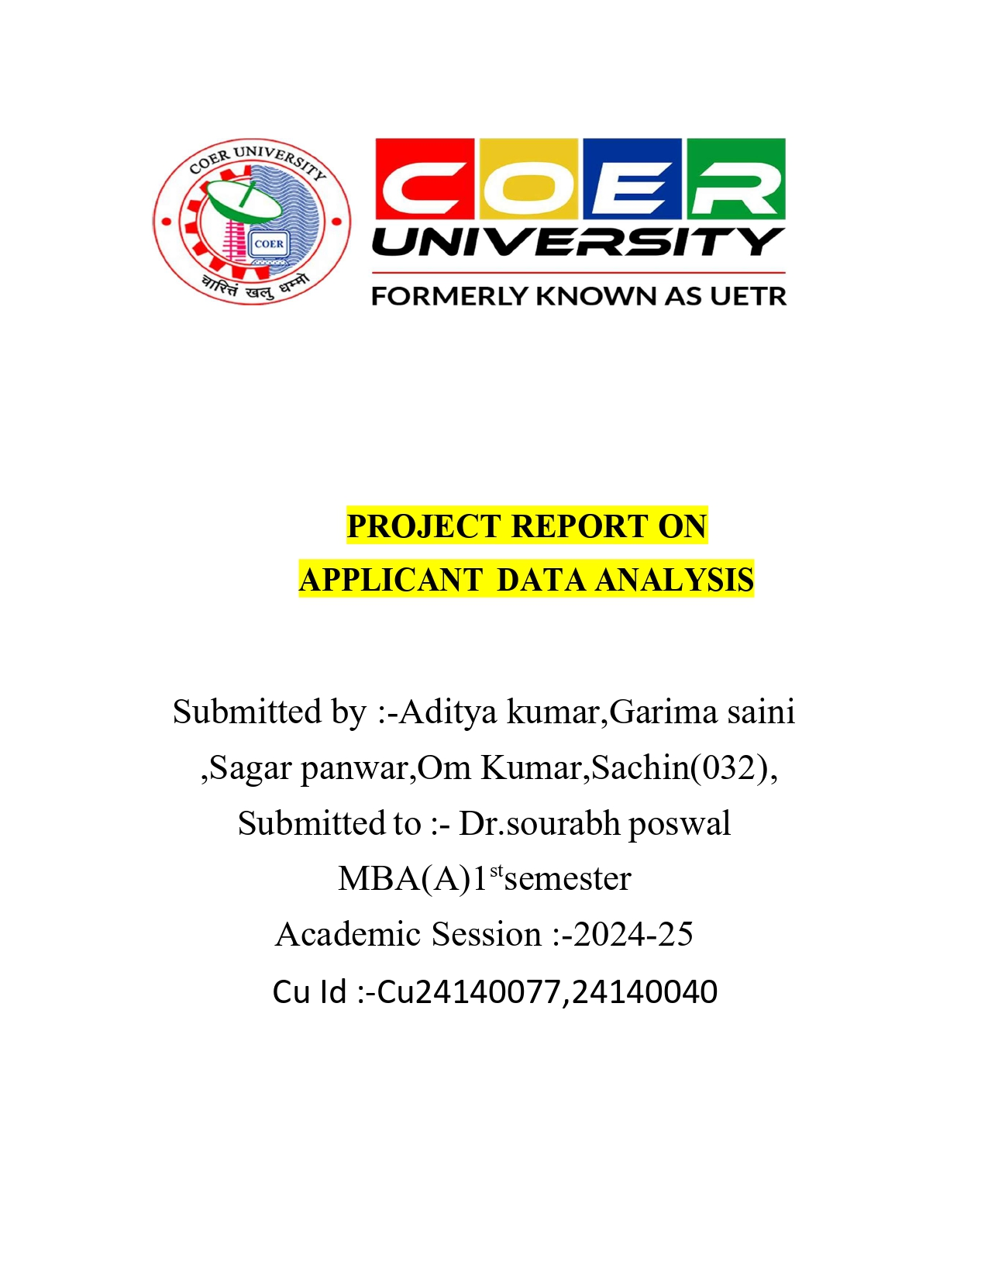

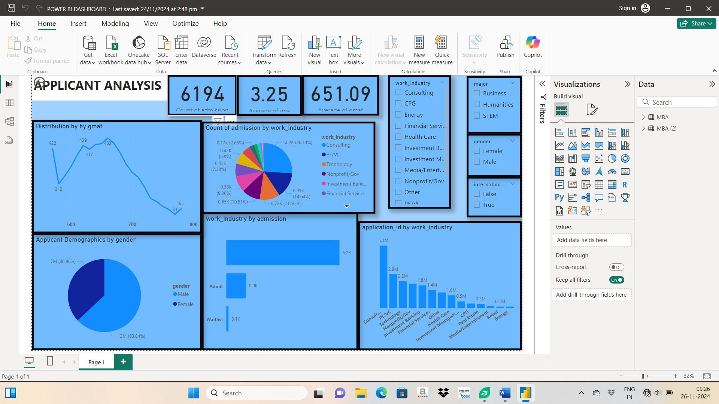**Project Report on Applicant Analysis**

‘

Executive Summary

This report provides an analysis of applicant data for admissions using a Power BI dashboard. The dashboard was designed to analyze trends in GMAT scores, demographics, work industries, and admission rates. Insights from this analysis aim to support strategic decisions in optimizing applicant selection and improving program outreach.

-

Project Objectives

Evaluate trends in GMAT scores and admission rates.

Analyze demographic and work-industry distributions.

Identify opportunities for program improvements and strategic outreach.

Provide insights to optimize the admission process.

Methodology

Data Collection: Data was sourced from internal admission records.

Data Cleaning: Outliers and missing values were managed to ensure data quality.

Visualization: Power BI was used for data modeling and creating interactive visuals.

Analysis: Key metrics like average GMAT score, work industry representation, and gender distribution were analyzed

Introduction

The dashboard focuses on analyzing applicant profiles for MBA admissions, including demographic details, GMAT performance, work industry distribution, and admission outcomes. The objective is to identify trends, understand data distribution, and drive actionable insights for business improvements.

Data Overview

Data Description:

Applicant data includes fields such as GMAT scores, gender, work industry, and admission status.

Categories analyzed: Admission counts, average GMAT, work industries, and gender representation.

Key Fields:

GMAT Scores

Work Industry Categories

Admission Status (Admit/Waitlist)

Gender

International/Local Applicants

Data Size: 6,194 total applicants.

Power BI Process

1. Data Import: Data was imported from Excel/SQL into Power BI.

2. Data Modeling: Relationships between tables were established.

3. Dashboard Design:

Key metrics like total admissions, average GMAT scores, and average GPA were highlighted.

Visualizations included pie charts, bar graphs, and line charts for comprehensive data presentation.

4. Slicers for Filtering: Filters for gender, work industry, and international/local applicants were implemented to enhance interactivity.

Visualization

Graphs Used:

Line Graph: GMAT score distribution.

Pie Chart: Gender and work-industry proportions.

Bar Chart: Admissions count by industry and application volume per work industry.

Purpose:

Highlight trends and proportions for a quick overview of key metrics.

Provide interactive insights using slicers for custom filtering.

.Insights and Analysis

Applicants with GMAT scores below 600 have limited admission chances, indicating a need for targeted improvement programs.

Gender disparity in applicants suggests the need for initiatives to increase female participation.

Industries like technology and healthcare are underrepresented, offering potential growth areas for outreach.

Key Findings

Average GMAT score of admitted applicants: 651.09.

Male applicants constitute a significant majority (69.56%).

Financial Services dominate admissions by industry (14.54%).

Admissions are heavily concentrated in a few industries, such as consulting and finance.

A small portion of applications comes from Nonprofit/Government sectors.

Business Recommendations

1. Outreach Expansion: Increase marketing efforts in underrepresented industries (e.g., technology, healthcare).

2. Scholarship Initiatives: Create scholarships for high-performing candidates from less-represented demographics.

3. Diversity Focus: Implement initiatives to attract more female and international applicants.

4. Improved Candidate Support: Provide resources to help candidates improve GMAT performance.

Limitations

Limited data representation from certain industries.

Data may not include external factors affecting admission outcomes (e.g., interview scores).

Possible bias due to overrepresentation of specific demographics or industries.

Conclusion

The dashboard provides a comprehensive view of applicant trends and admissions data, enabling stakeholders to make informed decisions. By addressing identified gaps, the program can enhance diversity and applicant quality.

Key Takeaways

Key metrics and visualizations offer quick insights into applicant trends.

Gender and industry disparities need attention for improved inclusivity.

Interactive filters provide flexibility for customized data exploration.

14. Business Impact

Improved strategic decision-making for admission

Enhanced diversity and inclusion metrics.

Targeted outreach can lead to higher applicant quality and diversity.

15. Future Improvements

Incorporate more variables, such as interview scores or work experience quality.

Use predictive analytics to forecast successful admissions.

Automate data updates for real-time dashboard insights.

Explore applicant feedback data to improve the overall application process.

This report highlights the dashboard's utility and offers actionable insights to optimize admissions processes and strategic goals.